



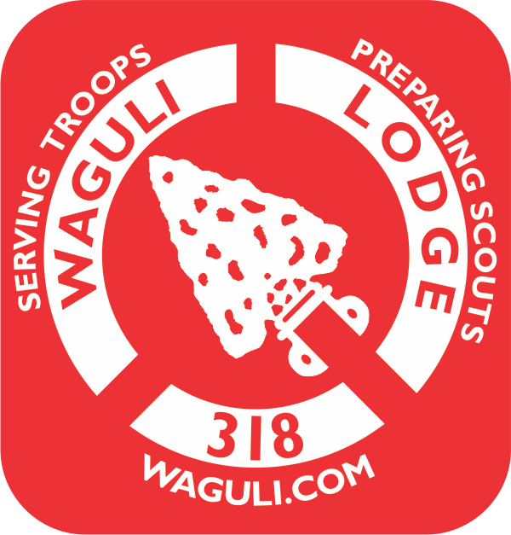

Waguli Lodge Camperships are open to all troops in the Northwest GA Council. Camperships are only available for Camp Sidney Dew Summer Camp 2017. These camperships for partial camp fee payment are provided to help boys who otherwise might not be financially able to attend camp.
In order for applications to be reviewed by the Campership Committee, applications must be turned in at least three weeks prior to the week the applicant is planning on attending. All applications are confidential. Funds are limited; the sooner applications are received the better. Camperships will be awarded as funds are available.
Name of Scout: ___________________________________________Date______________________
Name of Parent(s)/Guardian(s) :__________________________________________________
Contact Telephone Number: (H) (____) _______________ (M) (____)_________________
District: _________________________Unit #:___________ Unit Leader:_____________________
Chartered Organization:_____________________________________________________________
Summer Camp Week Scout plans to attend camp (Circle One):
Week 1( June 4-10) , Week 2 ( June 11-17) , Week 3 ( June 18-24)

How long as the Scout been registered in your Troop? _____________________
REASONS FOR REQUESTING CAMPERSHIP
Briefly provide an explanation for need, i.e. unemployed parent, disabled parent, low income family, etc. Tell a little about the applicants Scouting involvement.
(attach additional pages if necessary)
____________________________________________________________________________________________________________________________________________________________________________________________________________________________________________________________________________________________________________________________________________________________________________________________________________________________________
Does your Troop participate in Friends of Scouting this year? ---------Yes ____ No____
Does your Troop participate in Popcorn Sales last year? --------------- Yes _____ No _____
Does your Troop participate in Camp Card Sales this year? ------------- Yes _____ No _____
Total Amount Needed: $_________
Amount put forth by family: $________ -----------------------Amount put forth by unit: $________
Amount Requested of the Committee: $__________
Submitted by: ______________________________________ (please print)
Signature: _________________________________________ Relation to Scout: _____________________________
Contact Telephone (H) (____) ________________________ (M) (___) ____________________________
For Lodge Campership Selection Committee Use:
Date Received: __________________________
Amount Awarded: _______________________
When completed, send this form to:
Waguli Campership Committee
100 E. 2nd Ave., Suite 20
Rome, GA 30161
Or email to Wagulilodge@gmail.com

